Hi following explains the working of the program:

1. How to use the program

The program can be launched directly in the browser just copy the index.html path and paste in google chrome url box

1. Enter your inputs in these boxes and click ok to calculate the value

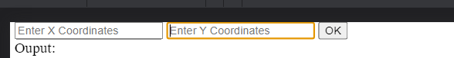

The input will be translated into an array:

X = [1, 2, ,3, 4]

Y = [1, 2, 3, 4]

Note the number can only be single digits

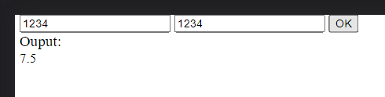

1. If an alphabet is passed it will consider it as 0

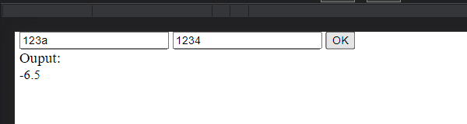

1. Lets say a scenario where there is [1,a,1,a] in x, the isolated integer 1 will be converted to 0 from both array(x and y) as it is an isolated area.

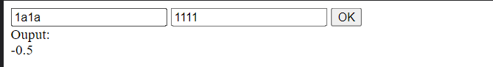

The result of the arrays is printed out on console you can check it out

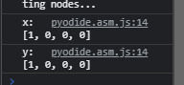

1. In another scenario we can say the 2nd element has been nullified the first element is isolated this means it needs to be nullified as well

